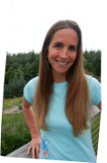
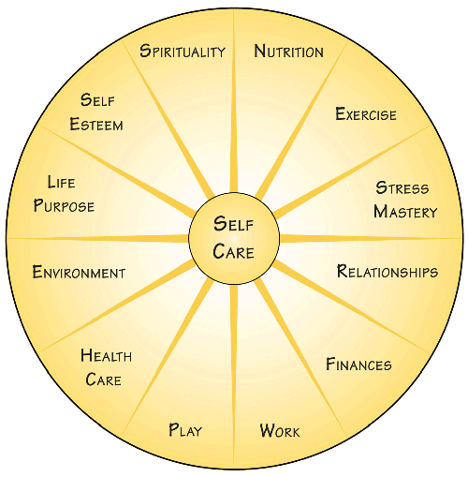
With this Holistic Wellness Program you will:
Join other women to leverage the collective knowledge, experience, wisdom, and successes that you've already experienced.
Design and step forward into a happier, healthier, and more balanced life.
Assess yourself in 12 life areas to define and clarify when your life calls for greater satisfaction and clarity.
Learn the process that will take you from where you are to where you want to be.
Celebrate your victories, using all outcomes as learning opportunities & stepping stones to future success and ongoing personal improvement.

I’d like to invite you to experience a gentle, fun & highly effective process for making and sustaining positive changes in your life and health.

Has the river of your life been moving so fast that you've been surviving instead of thriving?

Do you feel that you're not "on purpose" with your life?

Is there an area of your life where you feel stuck and would like to have a breakthrough towards greater joy and satisfaction?

Then this nationally acclaimed Circle of Life Wellness Program may be just what you need.

~ Susan James, MSSW,LICSW
Certified Health & Wellness Coach

Mind ✶ Body ✶ Spirit

Wellness Group for Women

Circle of Life

If you could add or change anything in your life

...what would it be?

Sign Up Today!

Six consecutive Tuesdays starting April 26th 7:30-9:30pm

on Bainbridge Island Cost: $240

Learn more at www.SusanJames.me

Intention ✶ Challenge ✶ Affirmation ✶ Action ✶ Accountability ✶ Support

